Your Brain Won’t Work As Well: Tips for Spiritual Leaders during Covid-19

[Mar 27](https://medium.com/@emilyscott_89364/your-brain-wont-work-as-well-tips-for-spiritual-leaders-during-covid-19-30aa71576dc5?source=post_page-----30aa71576dc5----------------------) · 3 min read (link to the article: <https://medium.com/@emilyscott_89364/your-brain-wont-work-as-well-tips-for-spiritual-leaders-during-covid-19-30aa71576dc5>)

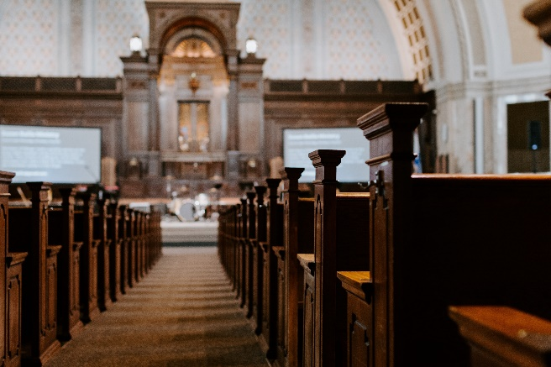

An empty house of worship. Photo by [Kelly Sikkema](https://unsplash.com/@kellysikkema?utm_source=unsplash&utm_medium=referral&utm_content=creditCopyText) on [Unsplash](https://unsplash.com/s/photos/empty-church?utm_source=unsplash&utm_medium=referral&utm_content=creditCopyText" \t "_blank)

I served as a clergy person through Hurricane Sandy in New York City. It was scary and hard, and while a hurricane is very different from what we’re facing now, working in the time of [#COVID19](https://www.facebook.com/hashtag/covid19?__cft__%5b0%5d=AZX4hH4Ll5lzCqZDv9foFhIJazKsms0NtnN_k8NkHeOE00aXEzDzSH1-4z2Jxql3-LLEGwcj7mpVZg5-oPt6cTZzoeHF-M21i8lV1ZeIWbQnsyf1zLh630P1AypNYnkCzHs&__tn__=*NK-R) has felt really familiar.

My brain is running too fast, I can’t catch my breath, and every so often I’m overwhelmed, thinking about those who are the most vulnerable. Right now, it’s like a big wave is crashing over us, or about to. But this is a big wave we can’t see.

What’s worse, our best tool for caring for people — gathering together has been taken from us. We’re called to offer presence, but right now presence places people at harm.

While this situation is like nothing I’ve ever experienced, during Sandy, i learned how to weather the storm. Here’s a few things I’ve learned about how to make it through, in the long haul.

**1. Your brain won’t work as well.**

This week I’ve forgotten what I was doing a thousand times. Stress messes with your sequencing, and ordering your thoughts gets hard. Try to do one thing at a time.

**2. Touch down once a day for the big picture, but focus on the tasks in front of you most of the day.**

There’s a lot to take in about how our world has changed. Take in news and new information once during the day, to make sure the work you’re doing in is in line with the new reality. But the rest of the time, focus on your work. Having something to focus on always gives me a sense of agency.

**3. Pause to assess your gifts and your vocation, and how they might meet the need in this current moment.**

If you’re incredible at pastoral care, focus on delivering it. If you’re great at building new structures, do that. We’ll all have to adapt in this new time, but lean on gifts God gave you, and take a breath to decide how to focus your time.

**4. Savor the sweet spots.**

It might be snuggling down under the covers when you first wake up or a cup of tea each night on the porch, but linger in the moments that give you comfort as long as you can.

**5. Do less.**

We can all do about 50–75% of what we did before this crisis hit. Let extra stuff fall away and streamline what you can.

**6. Sometimes, it’s time for triage.**

There are certain moments when we just jump in to make something happen. It’s good to move fast, but remember you’ll need to move slow afterward.

**7. Adapt and pivot**

Be as nimble as you can. We’re in a world that looks very different, and our organizations will need to shift to meet new needs. If you’re part of an organization that has a structure set up to serve others, how can that structure reach the \*most\* vulnerable, right now?

I know I said “do less” above, but also, it’s a time to “do differently” as well. Your church (or organization) might have resources, volunteers, or space. How can we be the church in this time, taking care of our members, and then stretching outward, to love our neighbors?

**8. Trauma will emerge**

I’ve noticed my body and mind shutting down this week, or my emotions racing out ahead of me. We can expect past traumas or current traumas to influence our days. Notice the signals your body’s sending you, and plan in time and energy for this.

**9. Rituals and structures of self care are key.**

Meditation at the beginning and end of the day. A long walk. A regular talk with a dear friend. Set up structures that will hold you through this time.

**10. You’re not God.**

If you’re the kind who thinks you have to rescue the whole world, remember that we’re in this together, and God is still here. There are people working for good in every setting — hospitals, libraries, schools, grocery stores. You can trust them to do their job, while you do yours.

[](https://medium.com/@emilyscott_89364?source=follow_footer--------------------------follow_footer-)

WRITTEN BY

[**Pastor Emily Scott**](https://medium.com/@emilyscott_89364?source=follow_footer--------------------------follow_footer-)

Follow

Emily is a pastor, activist, and church planter. Her book, “For All Who Hunger: Searching for Communion in a Shattered World,” will be out in May.