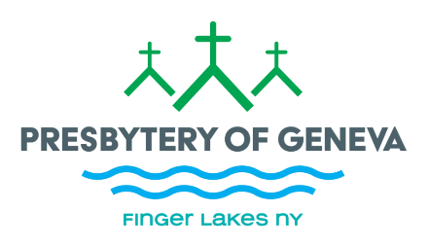
COMMITTEE ON MINISTRY
PRESBYTERY OF GENEVA, PC(USA)
Form 5: Attestation of Covenant/Call Arrangements through another denomination for Pastoral Services
The session of ________________________________ Church, a member of the Presbytery of Geneva, PC(USA), hereby attests that their pastor _______________________, a member in good standing of ________________________________ (denomination), has a covenant or call arrangement through that denomination for pastoral services effective ________________. This arrangement has been approved by the authorizing denomination. This covenant or call, if not open-ended, covers the period ______________________ to __________________. This covenant / call is to full time / ______________ service (specify if not full time).
Compensation, as detailed by the other denomination, is attached to this attestation for COM’s records but does not require COM or Presbytery approval.
The moderator of the session is _________________________ (if one is appointed by COM).
At the termination of the pastoral relationship, the session and pastor agree to participate in an evaluation of the relationship through the COM.

Signed: _______________ Clerk of Session Date: ________

_______________ Pastor Date: __________________

______________ for Committee on Ministry Date: ___________________

