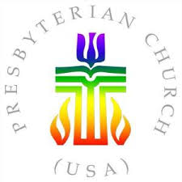
Non-Discrimination Policy:
________________, in keeping with our baptismal covenant vow to respect the dignity of every human being, have adopted the following policy of non-discrimination: ​Employment, membership, and participation in any church activity is open to all without regard to ethnicity, race, skin color, national origin, gender, sexual orientation, gender identity, gender expression, age, or disability.

